**Homework 10: Cryptography**

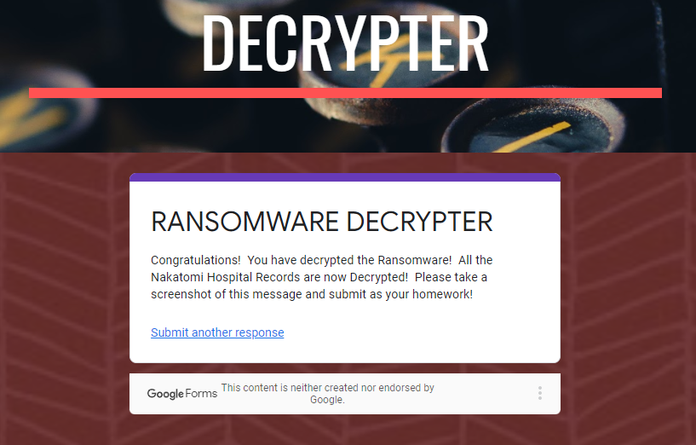

|  |  |  |
| --- | --- | --- |
|  | **Riddle Answers** | **Keys** |
| 1 | gruber | 6skd8s |
| 2 | Gennero | cy8snd2 |
| 3 | takagi | ud6s98n |
| 4 | Jill’s public key, Jill’s private key, 12 Asymmetric and 15 Symmetric, Alice’s public key | 7gsn3nd2 |
| 5 | argyle | ajy39d2 |
| 6 | mcclane | 7skahd6 |